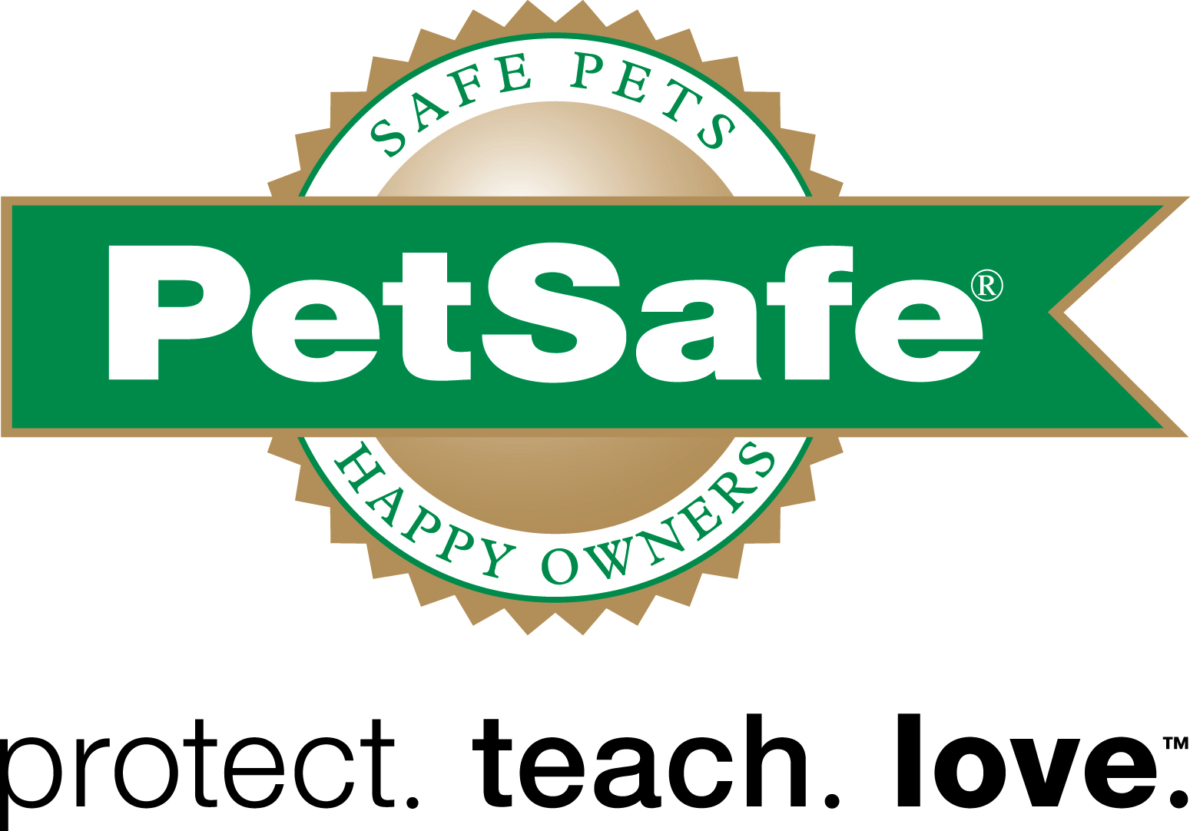
Media Contact:
Meredith Schneider
(919) 229-8001
meredith.schneider@fetchingcommunications.com

PetSafe® Brand to Donate up to 12,000 Toys to Pets at Animal Shelters Across the Nation Through Social Media Promotion
PetSafe will donate one toy to a shelter pet for each new social media “Like” or “Follow” through Dec. 31

KNOXVILLE, Tenn. (December 4, 2014) – PetSafe® brand, an industry leader in the development of innovative pet behavioral, containment, lifestyle product solutions and services, is helping share a little holiday joy to shelter pets across the nation this month. For every “Like” or “Follow” the brand receives on its Facebook, Twitter, Instagram and Pinterest accounts between now and Dec. 31, PetSafe will donate one toy to a pet in a shelter.

“PetSafe is proud to support these 12 organizations that are working hard to make their communities better for animals and people alike,” said Jim Tedford, PetSafe Director of Animal Welfare Initiatives. “Our tagline is ‘Protect. Teach. Love.’ and that’s exactly what we aim to do through this year’s ‘Joy of Toys’ campaign.”
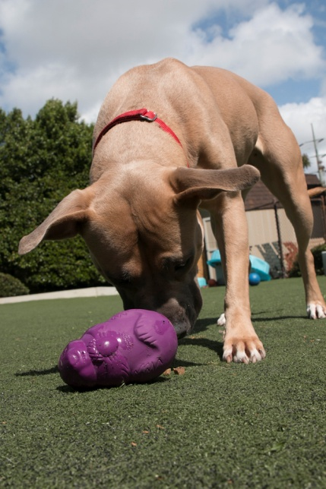
PetSafe aims to provide up to 12,000 of its Busy Buddy® and FroliCat™ brand cat and dog toys to pets in shelters across the U.S., including:

- Asheville Humane Society (Asheville, NC)
- Larimer Humane Society (Fort Collins, CO)
- Oregon Humane Society (Portland, OR)
- Halifax Humane Society (Daytona Beach, FL)
- Louisiana SPCA (New Orleans, LA)
- Capital Area Humane Society (Hilliard, OH)
- Atlanta Humane Society (Atlanta, GA)
- Kentucky Humane Society (Louisville, KY)
- Charleston Animal Society (N. Charleston, SC)
- Foothills Animal Rescue (Scottsdale, AZ)
- South Suburban Humane Society (Chicago Heights, IL)
- Austin Humane Society (Austin, TX)

To participate in PetSafe’s Joy of Toys campaign and help the brand donate a toy to a shelter pet, visit facebook.com/PetSafeBrand, twitter.com/PetSafe, instagram.com/PetSafe and pinterest.com/PetSafe and click “Like” or “Follow” by Dec. 31. Current fans and followers who would still like to help can participate by inviting their friends and family to like or follow PetSafe’s Facebook, Twitter, Instagram and Pinterest accounts.

For more information about PetSafe and its shelter outreach efforts, please visit www.petsafe.net.

About PetSafe® brand
Headquartered in Knoxville, Tenn., PetSafe® brand is an industry brand leader in the development of innovative pet behavioral, containment and lifestyle product solutions and services. For more information, please visit www.petsafe.net or connect with us on Facebook and Twitter.

# # #

